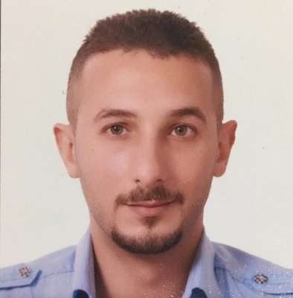

***Curriculum Vitae***

1. ***Personal Information* :-**

* Name : Mohammed Taha Yassen
* Place & Date Of Birth : Baghdad 25/03/1984
* Gender : Male
* Marital Status : Married
* Nationality : Iraqi
* Home Address : Iraq-Baghdad
* Mob. Number : 07726009371
* E-mail : [mtmdalal@gmail.com](mailto:mtmdalal@gmail.com)

**2*. Education ( Degrees ) :***

**University:-**

* Degree: Ibn al-Haytham college\computer science

Year of Graduation : 2007/2008

Average : Middle

University : Baghdad University

Research ofgraduation :-

Prepared Research paper in my specialized field as

Graduation requirement (code system)

**3-*Training programs***:

* International computer driving license (ICDL) from U.A.E 2009
* certificate of quality OF Internal Auditor (ISO 9001 )from UAE in 2012
* participation in forum on media reality and its implications in December 2012
* Attendance in intellectual giftedness in UAE privet schools workshop in 2014 form Synergy university Dubai campus
* Attendance in the program of small medical school of two levels from Emirate Medical association (EMA)
* Level one from 28 October to 25 November 2014
* Level two from 7 April 2014 to 5 May 2015
* Participation in program of (administrative and supervisory skills , Differentiated education , Microsoft office ) 2014-2015 In

Al –Rashid Al-Saleh privet school Dubai

* Person in Charge Certificate from Food Control Department Dubai Municipality

**4*. Experiences* :-**

**Outside Iraq (United Arab Emirates):**

1. work at AL-RASHID AL –SALEH PVT. SCHOOL Dubai

From 7 December 2010 to 13/12/2018:

* + Supervisor for food Department in school 2018 to 13/12/2018. licenced from Dubai Municipality .
  + transportation manager for 2 years (2016 & 2017) .
  + Member of the quality and development committee from 2012 to13/12/2018
  + Safety and security manager from 21- august -2016 to 13/12/2018
  + Health insurance officer from 2016 to 13/12/2018
  + Communication with the civil defence ,police , RTA in case of emergency and

other cases .

* supervisor in male section for 3 years (2013 ,2014 & 2015)
* supervisor assistant for 2 years in male section ( 2011 & 2012)

2. Work as media Consultant at Dubai Vacation Club Company 6 month.

3 . **Technical supervision and management in the Dubai Media Corporation**

**. Department of subscriptions and distribution Al Bayan newspaper (2008-2009 -2010)**

**in Iraq:**

1. Work at I D S (Iraq development & service)

**5.*Achievements:***

* Certificate of Thank and Appreciation form AL-RASHID AL –SALEH PVT. SCHOOL for great effort in 2011
* Certificate of Thank and Appreciation form AL-RASHID AL –SALEH PVT. SCHOOL for great effort in 10-March-2012
* Certificate of Thank and Appreciation form AL-RASHID AL –SALEH PVT. SCHOOL for great effort in )2013-2014( year
* Certificate of Thank and Appreciation form AL-RASHID AL –SALEH PVT. SCHOOL for great effort in )2015-2016( year
* Certificate of Thank and Appreciation form AL-RASHID AL –SALEH PVT. SCHOOL in 24-feb.-2016 for great effort in safety and security
* Certificate of Thank and Appreciation form AL-RASHID AL –SALEH PVT. SCHOOL in 24-jan.-2017 for the great effort in the year (2016-2017**)**
* Certificate of Thank and Appreciation form AL-RASHID AL –SALEH PVT. SCHOOL in 24-May-2017 for great effort
* Certificate of Thank and Appreciation form AL-RASHID AL –SALEH PVT. SCHOOL 30-jan.-2017 for great effort in safety and security in evacuation process in 18-jan.-2017
* Certificate of Thank and Appreciation form AL-RASHID AL –SALEH PVT. SCHOOL 30-jan.-2017 for great effort in safety and security in evacuation process in 18-jan.-2017
* Certificate of Thank and Appreciation form AL-RASHID AL –SALEH PVT. SCHOOL in 29-Jan-2018 for great effort

**5 -*other skills*:**

* Microsoft office programs
* Internet researches
* Multicultural understanding
* Leadership and supervision
* Time management
* Planning and scheduling
* Decision making
* Safety and security management
* Quality and development managing
* Team work
* Work under pressure
* Ability to learn and self-development

**6*. Languages*:-**

* Arabic fluent
* English